SOP - Return Invoice Data Entry

This Standard Operating Procedure (SOP) document details the comprehensive process for accurately and efficiently entering return invoices into the Emperor system. Users are required to adhere to the outlined steps when utilizing the IBM RPA bot launcher to input return invoice data. This automation tool streamlines the data entry process, minimizing manual errors and improving overall operational efficiency.

## Step 1 : Prerequisites:

To ensure successful operation of the IBM RPA bot, please verify the following:

1. **Folder Access:** Confirm you have access to the following network location:  
   \\92.168.6.152\ignetmain\F-Drive\Individuals\IMPACT.DEO\SALES.IMPACT\SALLES.BILLING\5-2026\IBM RPA
2. **Display Scaling:** Set your screen scaling to 100% zoom. Incorrect scaling may lead to a custom DPI configuration error when launching the Emperor system.
3. **Emperor System Installation:** Ensure the Emperor system is installed on your computer.
4. **IBM RPA Bot Launcher:** Verify that the IBM RPA bot launcher is installed on your system and you possess valid login credentials.

## Step 2 : Input Excel Preparation:

To ensure the successful execution of the automated process, precise preparation of the input Excel file is paramount. This step outlines the necessary actions to configure your data for seamless integration with the IBM RPA system.

1. **File Location:**

The designated directory for the input Excel file is located on the shared network drive. You must place the file within the following specific path:

\\92.168.6.152\ignetmain\F-Drive\Individuals\IMPACT.DEO\SALES.IMPACT\SALLES.BILLING-2026\IBM RPA\input_file\

It is crucial to verify that the file is placed exactly in this location to allow the RPA bot to access it without any path-related errors.

1. **File Naming Convention:**

The input Excel file **must** be named input_excel.xlsx. Any deviation from this exact filename will prevent the RPA bot from recognizing and processing the file. Ensure that no other files with similar names are present in the directory, as this could lead to confusion or errors.

1. **Data Structure and Headings:**

The data within input_excel.xlsx must adhere to a predefined structure. The system expects a consistent layout to correctly interpret the information. Specifically, the headings of the columns are constant and **must not be altered**.

Please refer to the "below picture shown" for a precise depiction of the required data structure and the exact spellings of the column headings. This visual guide is critical for ensuring accurate data formatting and alignment with the RPA system's expectations.

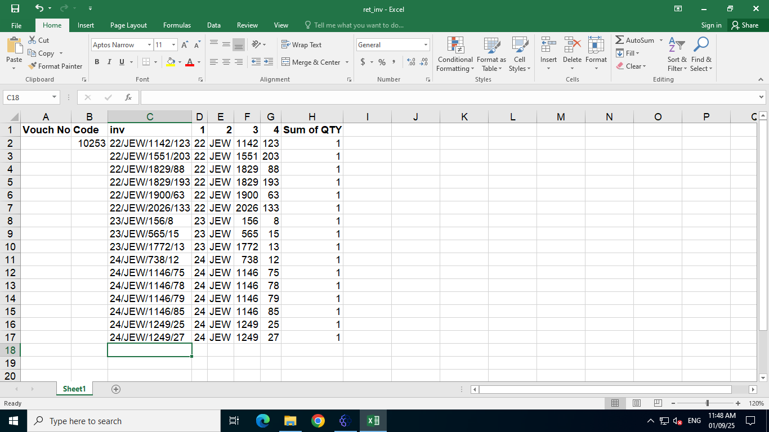

* Please ensure the file is closed after saving the data so that RPA can access it.

## Step 3: Launching the Bot from IBM RPA Launcher

To get into the IBM RPA Launcher, you'll need to log in with your username and password. If you do not have these credentials, please contact your IBM RPA Administrator. Follow the below steps to log into the IBM RPA Launcher and start the bot execution.

1. Navigate to the desktop and double-click the "IBM RPA Launcher" icon to start the application.

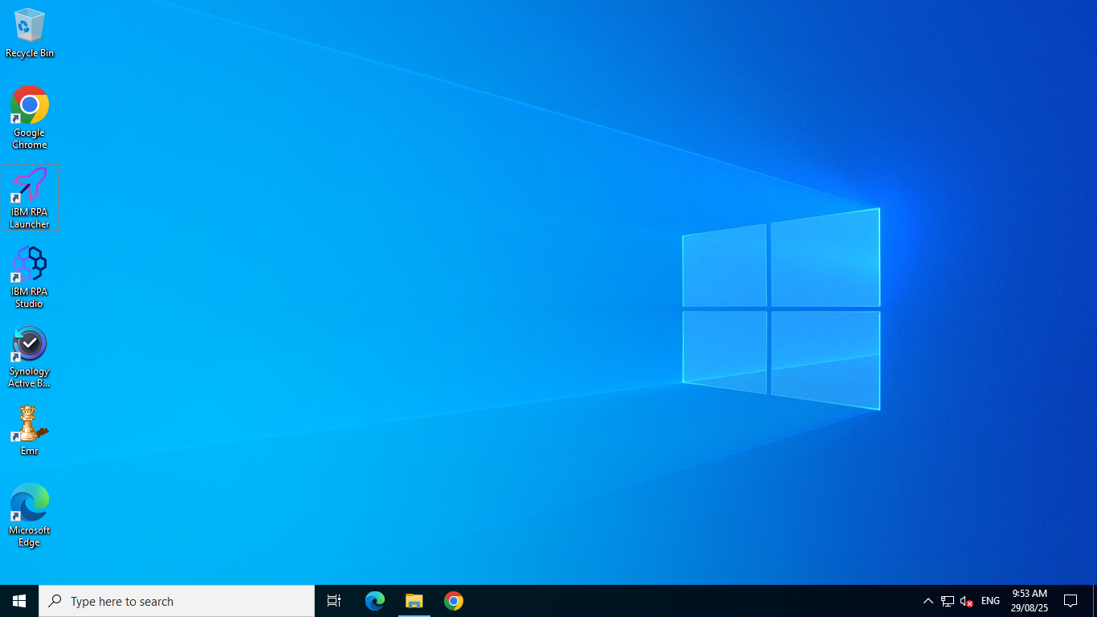

1. Obtain your email ID and set your password, then log in to the RPA launcher by entering your email and clicking "Continue."

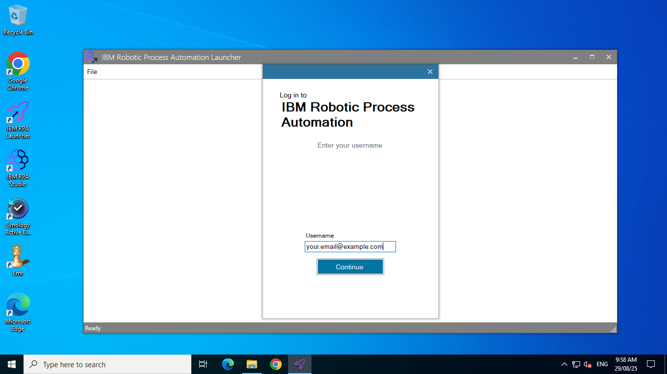

1. On the next screen, input your password and click "Login" to access the launcher.

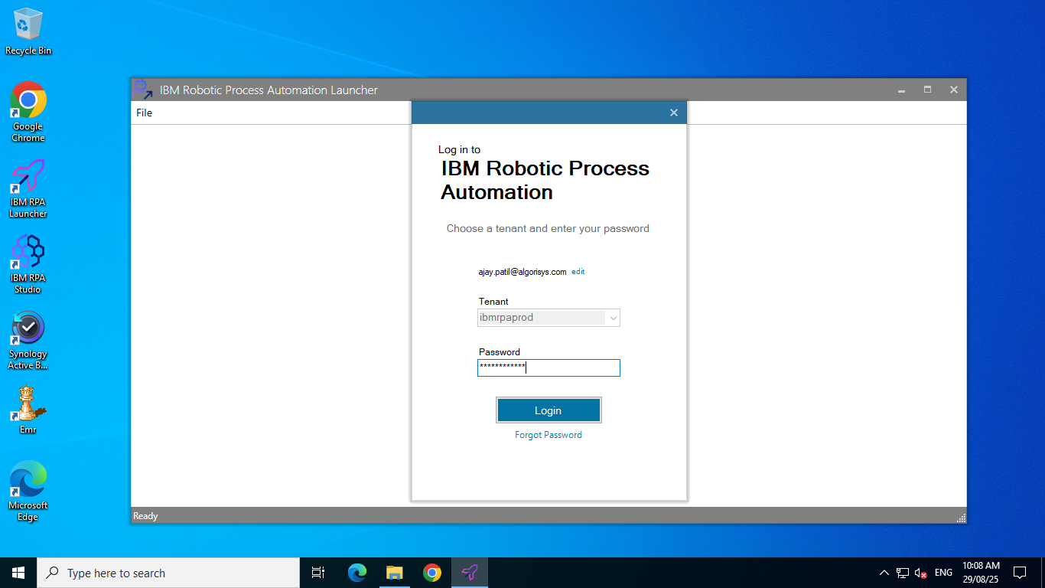

1. After login on the launcher's main screen, double-click the "**Return Invoice Data Entry**" button to initiate the bot's execution. You will see the name "Return Invoice Data Entry" displayed at the top.

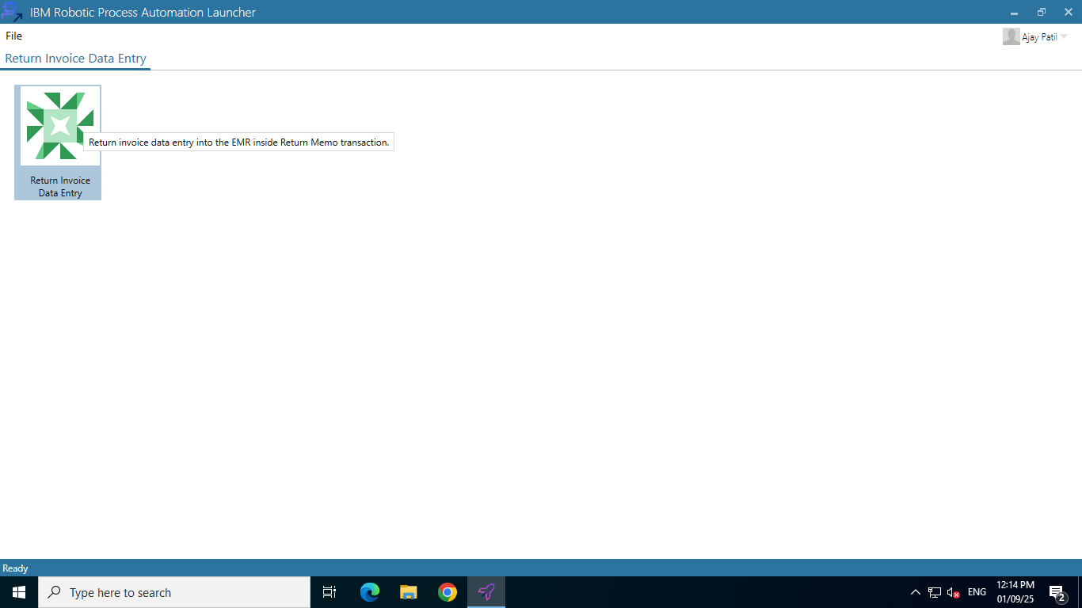

* After successfully initiating the bot, the next crucial step is to minimize the launcher screen. This action will allow you to access the main interface of the Emperor, where you can proceed with further operations. Minimizing the launcher ensures that it does not obstruct your view or interfere with your workflow as you navigate the Emperor Application.

## 

## Step 4: Select Voucher Number and Input Emperor Login Credentials

1. At first a message box will appear, asking you whether you want to start a new voucher.
2. **Yes**: A new voucher number, greater than the previous one, will be assigned, and you can begin data entry.
3. **No**: You will be asked to enter the voucher number and the record row from which you wish to insert data.

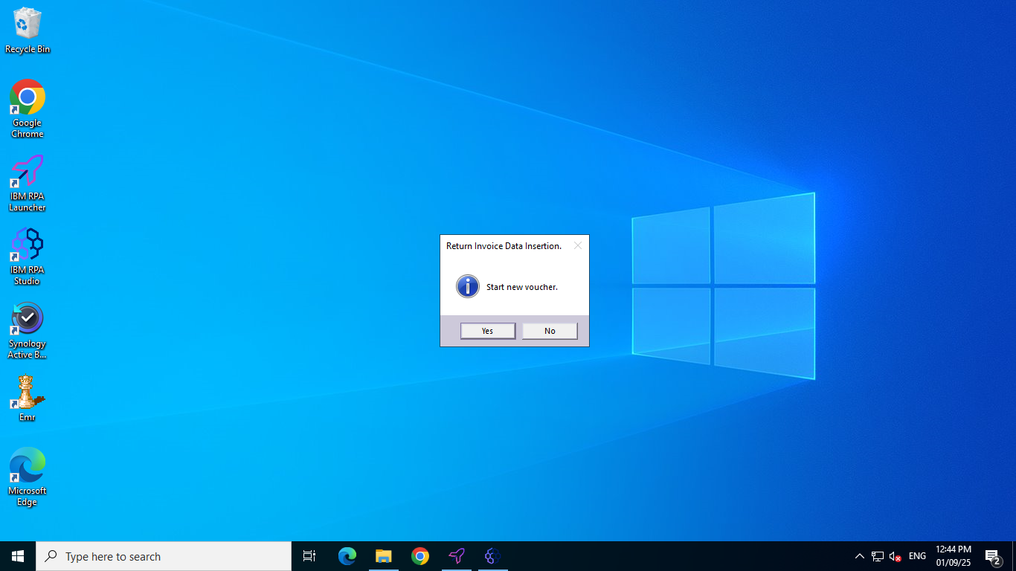

1. In the next step you will be asked to enter a username for the Emperor system. After entering the username click on the **Ok** button.

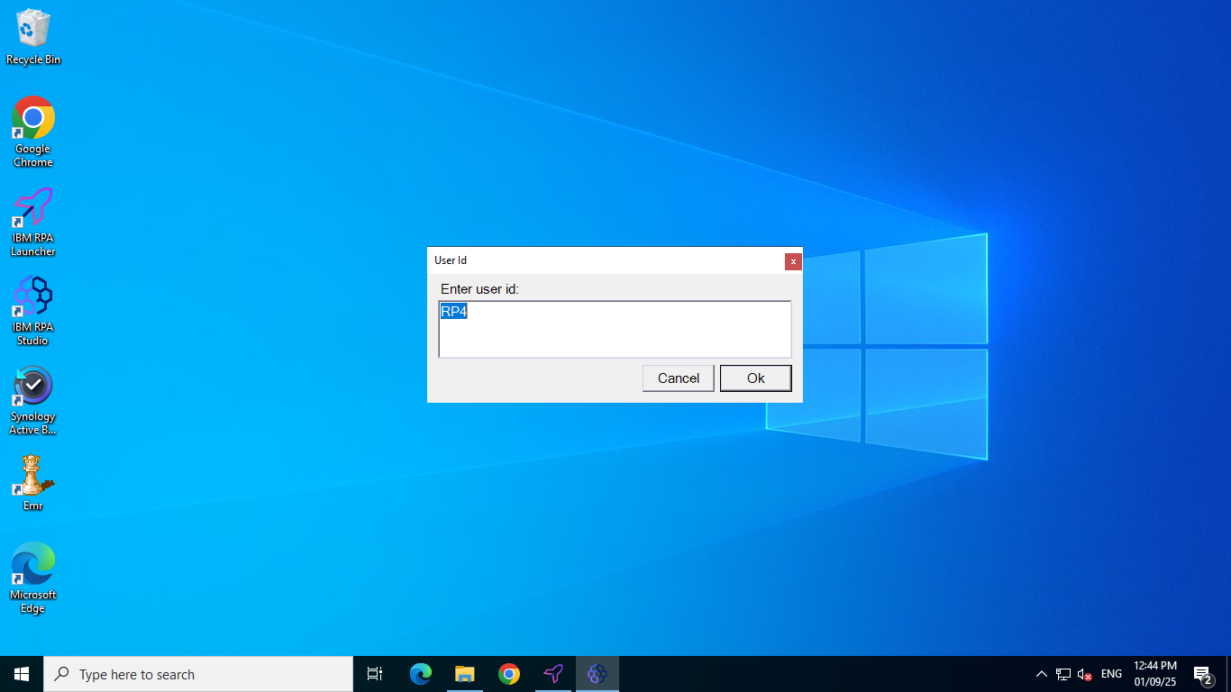

1. Next you will be asked to enter the password for your username to login to the Emperor system, enter the password and click on the **OK** button.

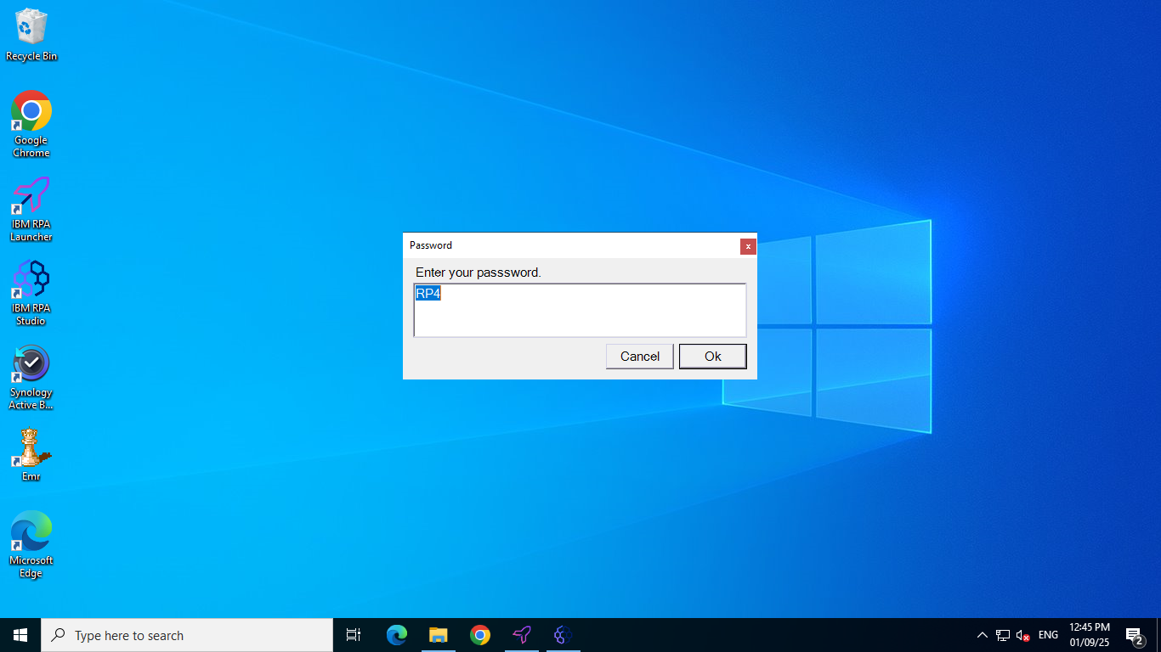

1. If you click ‘**No**’ at ‘**1**’ so you will append the data into the old voucher now will be asked to enter the row number from which you want to enter insert the data else go to ‘**6**’. Enter the row number and click on ‘**OK**’.

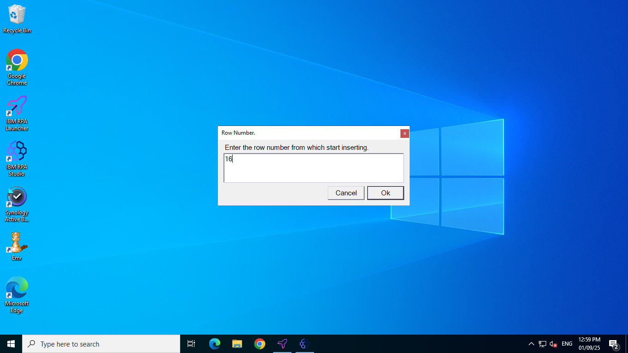

1. Next you need to enter the old voucher number in which you want to append the data. Enter voucher number and click on ‘OK’ to continue.

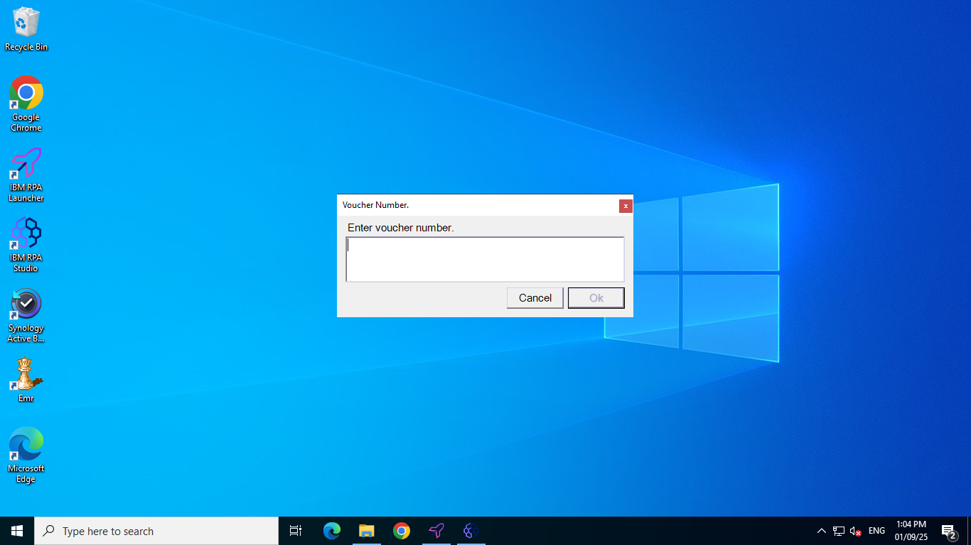

1. Wait until the login window of the emperor system appears and when the window is visible you will need to click on the first input box of the login which is ‘**Company Cd**’.

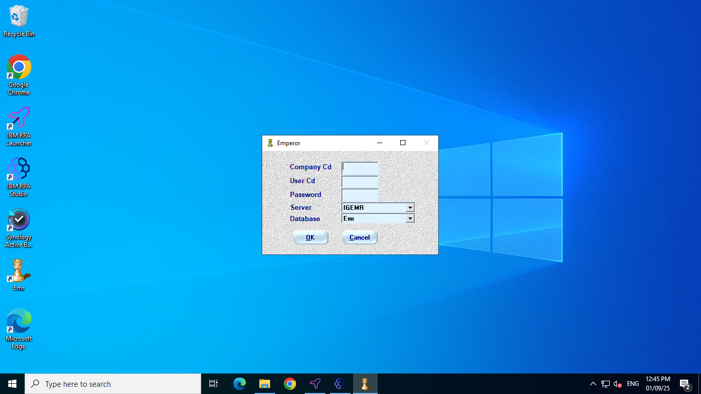

1. The bot will automatically insert the login credentials, enter’s company code, usercode given at step ‘**2**’ and password given at step ‘**3**’, select’s server and database and log into the Emperor system.

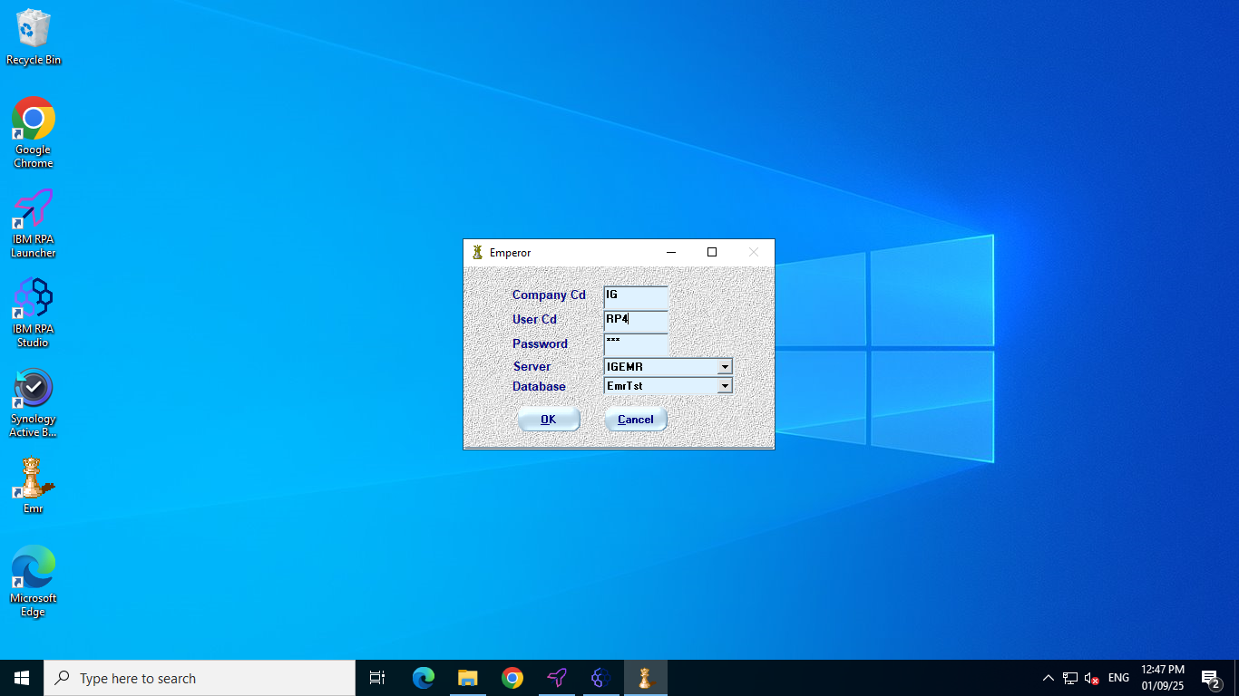

1. From the main menu of the Emperor main screen, the bot selects 'Return Memo' from the ‘Transactions’.

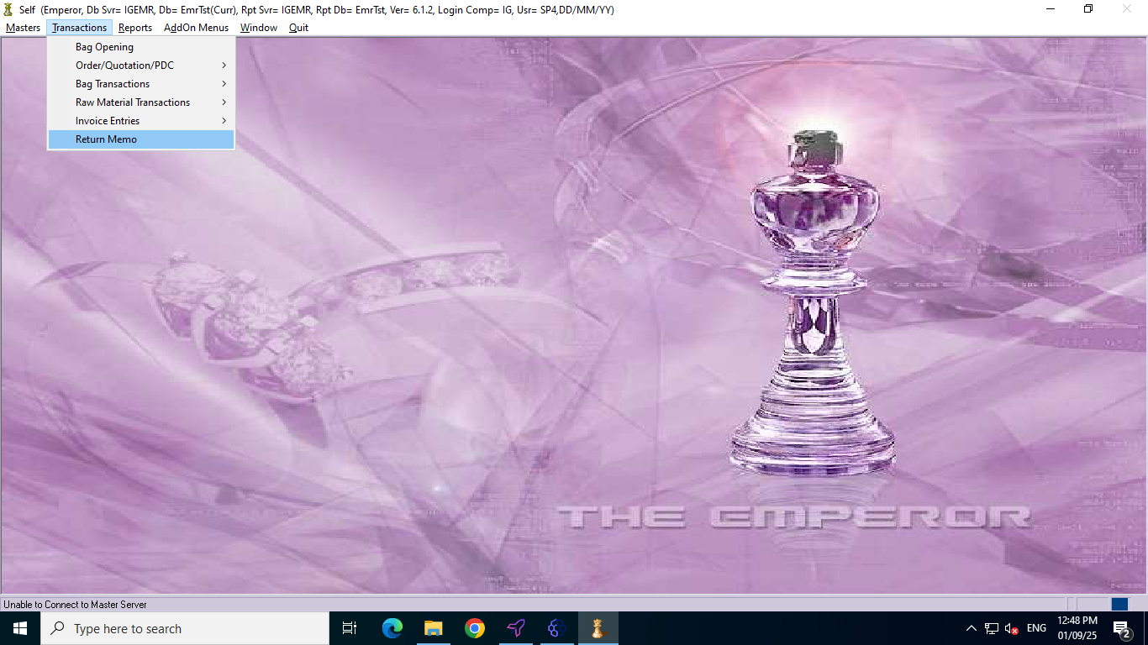

1. Return memo form will appear based on the user preference of new or old voucher the corresponding voucher will be found/add.

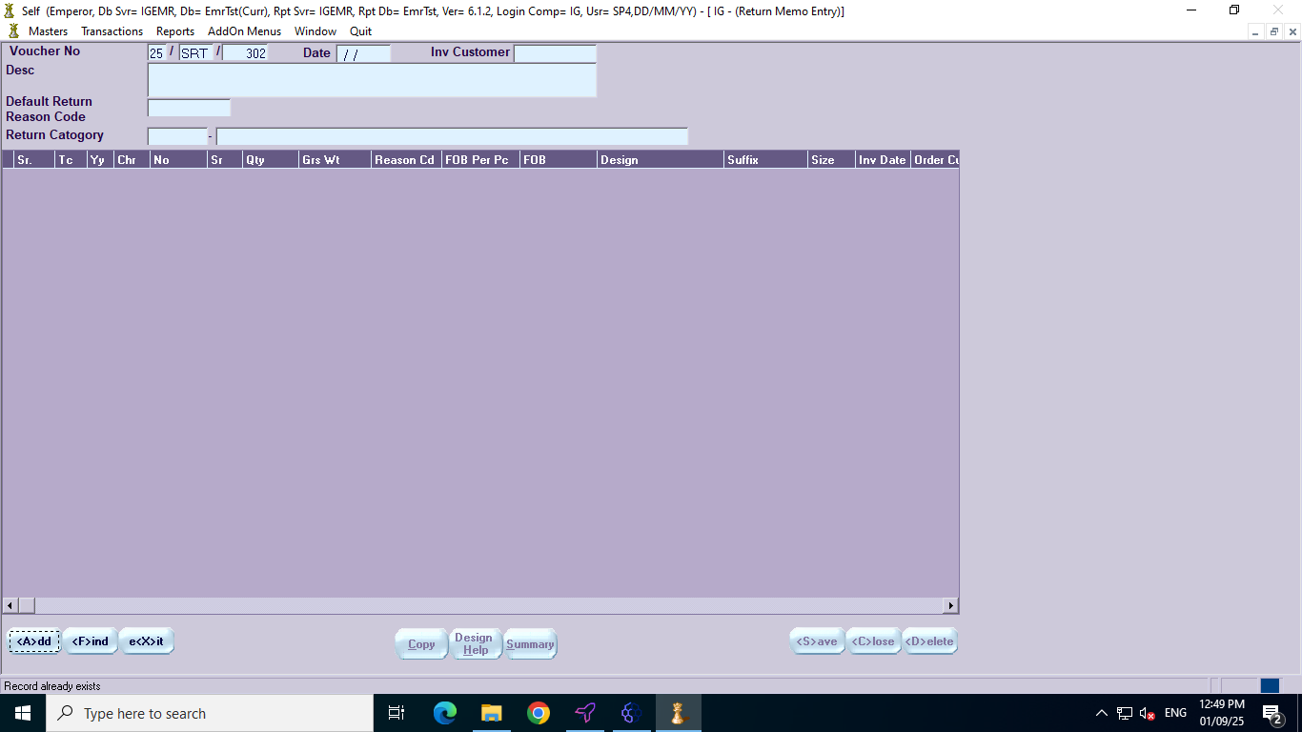

1. Each record from the spreadsheet will be processed individually and inserted into the corresponding fields within the return memo form. This sequential insertion ensures accuracy and maintains the order of the original data. Upon the successful completion of data entry for all records, the system will automatically save and terminate, signifying the end of the process.

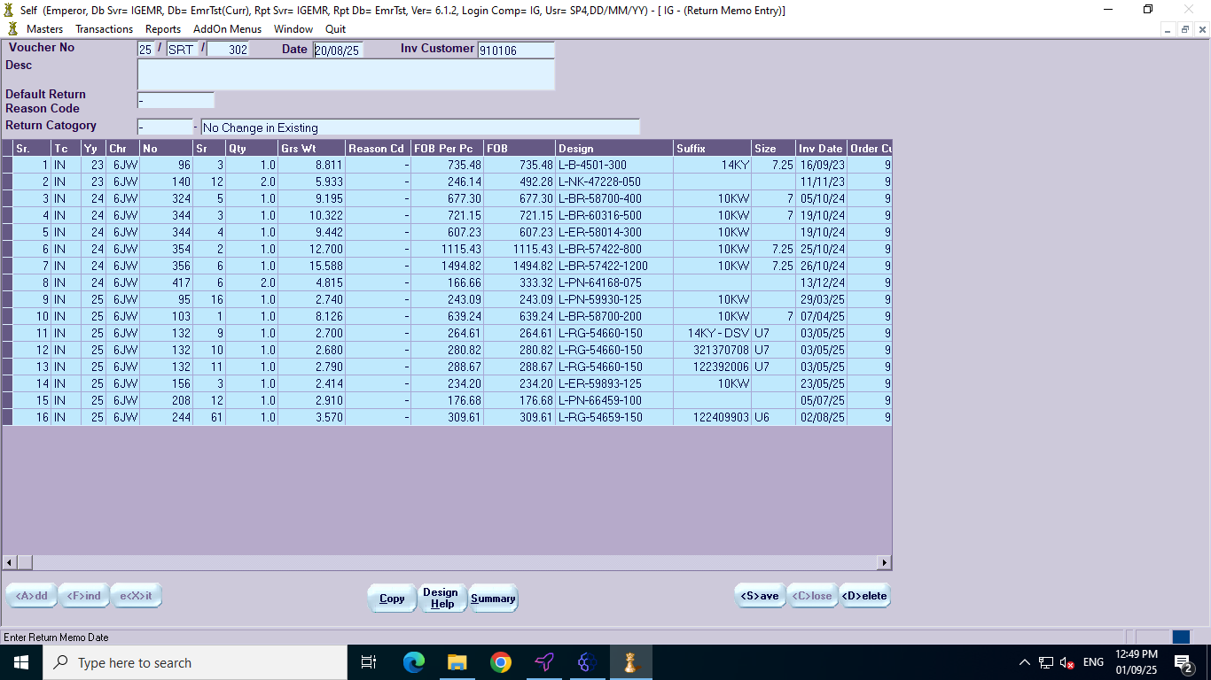

**Return Invoice Data Entry: Final Verification and Completion**

Upon reaching this stage, the meticulous process of return invoice data entry is considered complete. It is crucial to perform a thorough verification to ensure the accuracy and integrity of the appended data. The automated bot, responsible for the data entry, should have seamlessly integrated all relevant information.